**Lord of the Valley Lutheran Church**

PO Box 843 Granby, CO 80446 (970)887-9252

**Ministers:** All God’s People **Pastor:** Rob Moss

__________________________________________________________________

**LOTV Worship with Holy Communion**

**Sunday, February 9, 2025 Fifth Sunday after Epiphany**

**Welcome and Announcements**

P: The grace of our Lord Jesus Christ, the love of God, and the communion of the Holy Spirit be with you all.

**C: And also with you.**

**Epiphany Confession and Forgiveness**

P: God of Light,

**C: We have lived in darkness for too long. We have built walls of isolation so high that the sun is no longer visible. We have a fortress of protection so complete that the sun cannot penetrate. We have stumbled down dark alleys in search of real meaning. God of light and life, illuminate the rooms of our life with your light, and draw us closer to you. Forgive the sin which keeps us in our private darkness. Allow us to live in the light of your freedom and acceptance.**

P: Our God is Light and life. Our God has brightened our days with hope and exposed every dark corner of our lives with grace and mercy. The Light of life is Christ Jesus, who brings the compassion of God’s brightness into a dark world. In Jesus, we live in the light of our Creator and know the joy of hope and community.

**C: We give thanks to God for light and new life! Amen!**

**Tree of Life**

**Gathering Song** *“Come and Gather Beneath the Tree of Life”*

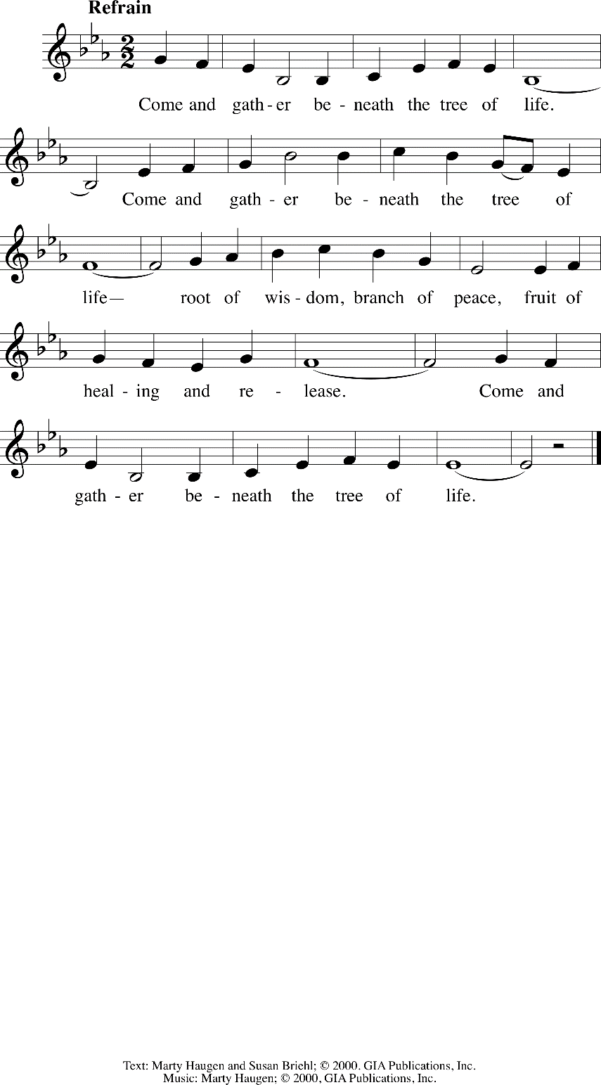

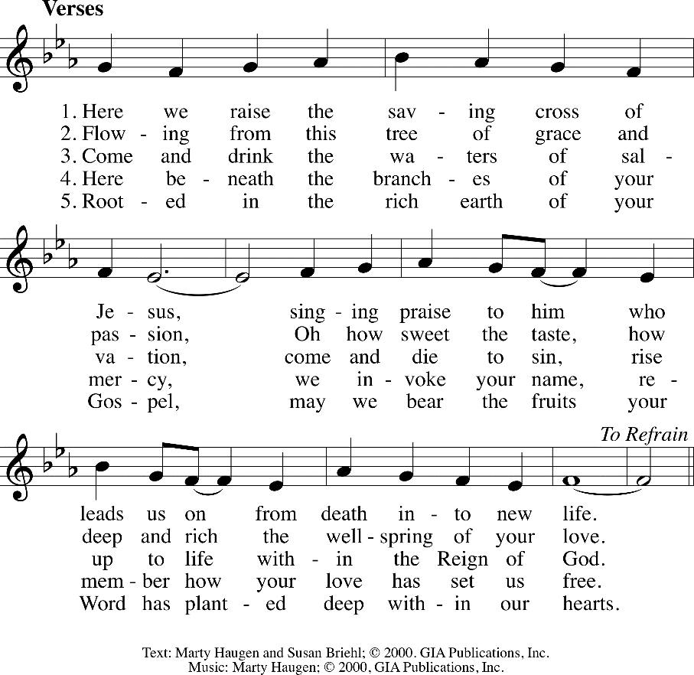

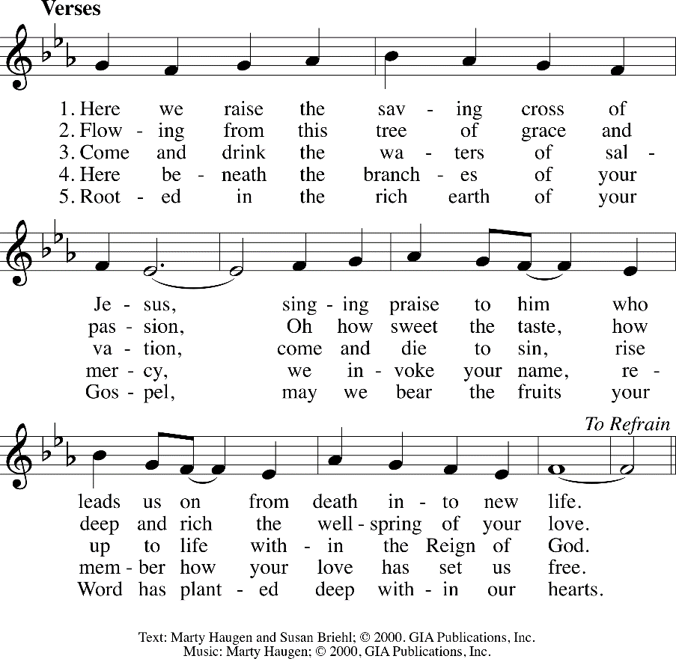

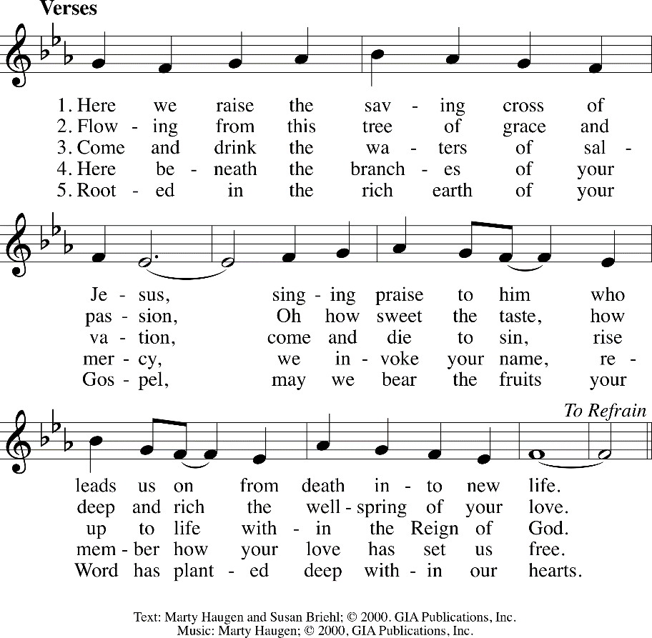

**Epiphany Litany** (*based on Isaiah 60:1-6)*

A: Arise! Shine! The light you have been waiting for is here!

**C: Darkness has been banished!**

A: God's light of hope floods the earth.

**C: God's light comes to us all.**

A: O, God, make us ready to journey in this Light.

**C: In this time of worship, prepare our hearts to live in your marvelous Light. Amen.**

**Song of Praise “***Within the Reign of God”*

*(The congregation sings the verse response and the refrain)*

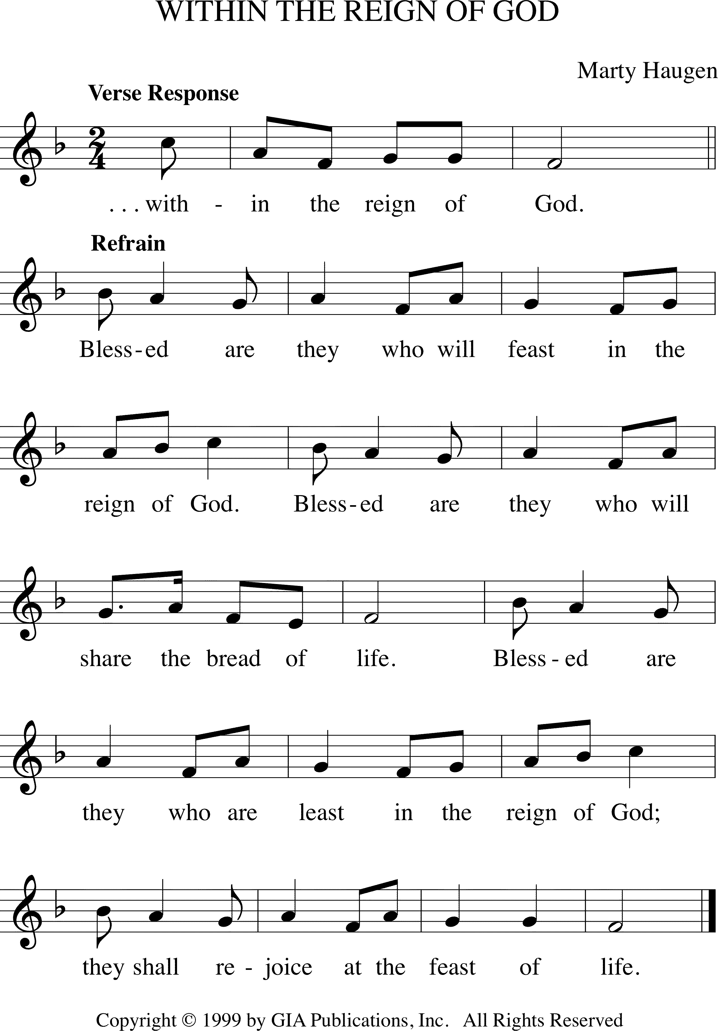

**Verse:** Come now, the feast is spread; in Jesus’ name we break the bread,

Here shall we all be fed, **WITHIN THE REIGN OF GOD**

All you who seek God’s face are welcome in this holy place;

Join in the feast of grace, **WITHIN THE REIGN OF GOD**

*(Refrain)*

**Verse:** Welcome the weak and poor, the sinner finds an open door,

None judged, and none ignored **WITHIN THE REIGN OF GOD**

Here shall the weary rest, the stranger be a welcome guest.

So shall we all be blest, **WITHIN THE REIGN OF GOD**

*(Refrain)*

**Verse:** One earth, one holy band, one family as our God has planned,

All share the promised land, **WITHIN THE REIGN OF GOD**

Come now, the feast is spread, in Jesus’ name we break the bread;

Here shall we all be fed, **WITHIN THE REIGN OF GOD**

*(Refrain)*

**Prayer of the Day**

P: The Lord be with you.

**C: And also with you.**

P: Let us pray,

**C: Most holy God, the earth is filled with your glory, and before you angels and saints stand in awe. Enlarge our vision to see your power at work in the world, and by your grace make us heralds of your Son, Jesus Christ, our Savior and Lord. Amen.**

**Bible Readings**

**Isaiah 6: 1-8 [9-13]**

In the year that King Uzziah died, I saw the Lord sitting on a throne, high and lofty; and the hem of his robe filled the temple. Seraphs were in attendance above him; each had six wings: with two they covered their faces, and with two they covered their feet, and with two they flew. And one called to another and said:  
‘Holy, holy, holy is the Lord of hosts;  
the whole earth is full of his glory.’  
The pivots on the thresholds shook at the voices of those who called, and the house filled with smoke. And I said: ‘Woe is me! I am lost, for I am a man of unclean lips, and I live among a people of unclean lips; yet my eyes have seen the King, the Lord of hosts!’

Then one of the seraphs flew to me, holding a live coal that had been taken from the altar with a pair of tongs. The seraph touched my mouth with it and said: ‘Now that this has touched your lips, your guilt has departed and your sin is blotted out.’ Then I heard the voice of the Lord saying, ‘Whom shall I send, and who will go for us?’ And I said, ‘Here am I; send me!’[ And he said, ‘Go and say to this people:  
“Keep listening, but do not comprehend;  
keep looking, but do not understand.”  
Make the mind of this people dull,  
   and stop their ears,  
   and shut their eyes,  
so that they may not look with their eyes,  
   and listen with their ears,  
and comprehend with their minds,  
   and turn and be healed.’  
Then I said, ‘How long, O Lord?’ And he said:  
‘Until cities lie waste  
   without inhabitant,  
and houses without people,  
   and the land is utterly desolate;  
until the Lord sends everyone far away,  
   and vast is the emptiness in the midst of the land.  
Even if a tenth part remains in it,  
   it will be burned again,  
like a terebinth or an oak  
   whose stump remains standing  
   when it is felled.’  
The holy seed is its stump.

**1 Corinthians 15: 1-11**

Now I should remind you, brothers and sisters, of the good news that I proclaimed to you, which you in turn received, in which also you stand, through which also you are being saved, if you hold firmly to the message that I proclaimed to you—unless you have come to believe in vain.

For I handed on to you as of first importance what I in turn had received: that Christ died for our sins in accordance with the scriptures, and that he was buried, and that he was raised on the third day in accordance with the scriptures, and that he appeared to Cephas, then to the twelve. Then he appeared to more than five hundred brothers and sisters at one time, most of whom are still alive, though some have died. Then he appeared to James, then to all the apostles. Last of all, as to someone untimely born, he appeared also to me. For I am the least of the apostles, unfit to be called an apostle, because I persecuted the church of God. But by the grace of God I am what I am, and his grace towards me has not been in vain. On the contrary, I worked harder than any of them—though it was not I, but the grace of God that is with me. Whether then it was I or they, so we proclaim and so you have come to believe.

**Gospel Acclamation**

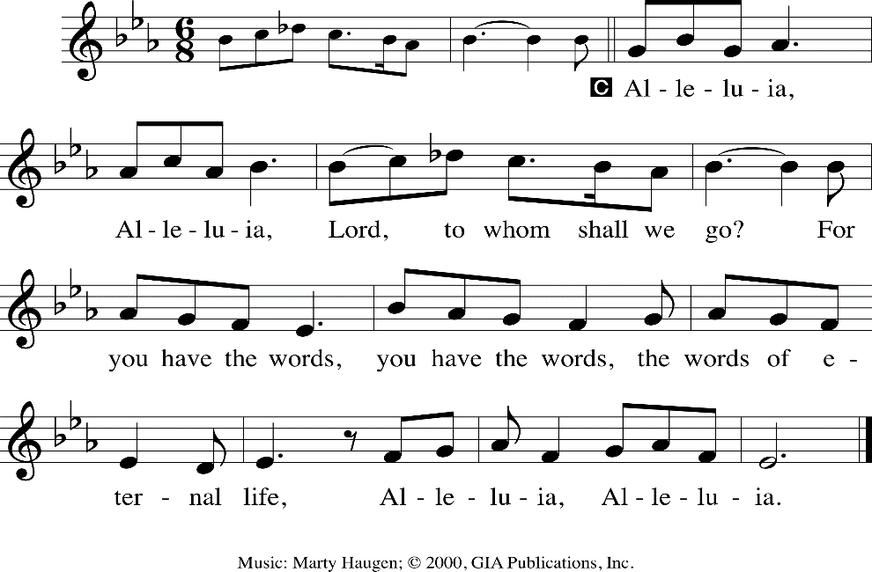

**Gospel**

**Luke 5: 1-11**

Once while Jesus was standing beside the lake of Gennesaret, and the crowd was pressing in on him to hear the word of God, he saw two boats there at the shore of the lake; the fishermen had gone out of them and were washing their nets. He got into one of the boats, the one belonging to Simon, and asked him to put out a little way from the shore. Then he sat down and taught the crowds from the boat. When he had finished speaking, he said to Simon, ‘Put out into the deep water and let down your nets for a catch.’ Simon answered, ‘Master, we have worked all night long but have caught nothing. Yet if you say so, I will let down the nets.’ When they had done this, they caught so many fish that their nets were beginning to break. So they signalled to their partners in the other boat to come and help them. And they came and filled both boats, so that they began to sink. But when Simon Peter saw it, he fell down at Jesus’ knees, saying, ‘Go away from me, Lord, for I am a sinful man!’ For he and all who were with him were amazed at the catch of fish that they had taken; and so also were James and John, sons of Zebedee, who were partners with Simon. Then Jesus said to Simon, ‘Do not be afraid; from now on you will be catching people.’ When they had brought their boats to shore, they left everything and followed him.

**Children’s Message and Sunday School Dismissal**

**Sermon**

**Hymn of the Day** “If You But Trust in God to Guide You”

**Prayers of the People**

A: God of grace,

**C: hear our prayer.**

**Offering**

**Offering Response** “*Come, Let us Bring”*

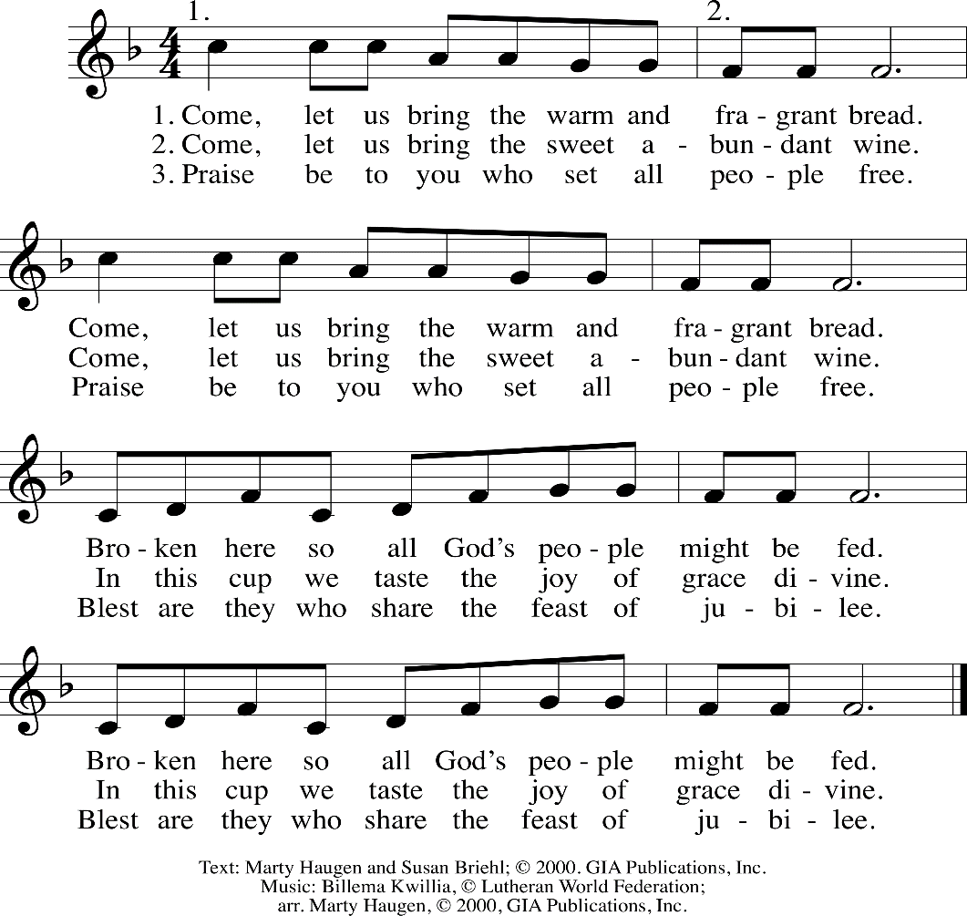

Leader: Let us pray. Merciful God,

**ALL: Everything in heaven and earth belongs to you. We joyfully release what you have entrusted to us. May these gifts be signs of our whole lives returned to you, dedicated to the healing and unity of all creation, through Jesus Christ. Amen.**

**The Great Thanksgiving**

P: The Lord be with you.

**C: And also with you.**

P: Lift up your hearts.

**C: We lift them to the Lord.**

P: Let us give thanks to the Lord our God.

**C: It is right to give our thanks and praise.**

P: It is indeed right and good…we praise your name and join their unending hymn:

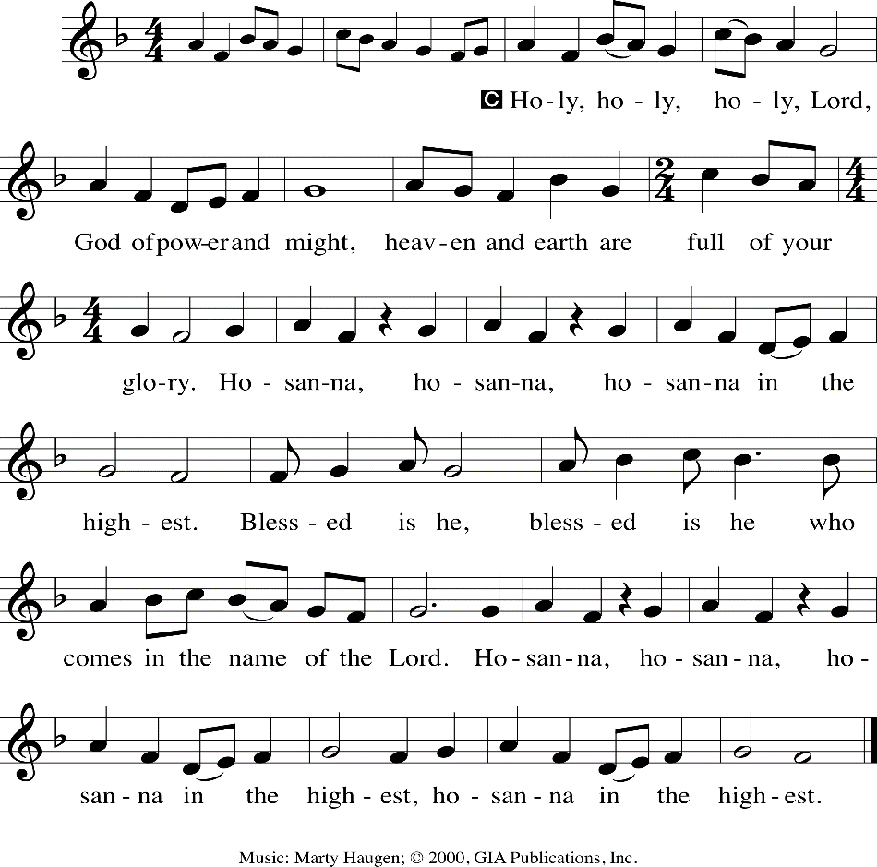

**Words of Institution**

**Lord’s Prayer**

Leader: Lord, remember us in your love and teach us to pray.

**ALL: Our Father, who art in heaven, hallowed be thy name. Thy kingdom come. Thy will be done; on earth as it is in heaven. Give us this day our daily bread; and forgive us our trespasses as we forgive those who trespass against us; and lead us not into temptation, but deliver us from evil; For thine is the kingdom, and the power and the glory forever and ever. Amen.**

**Distribution of Communion**

*We invite all who come in faith to the Lord’s Table as we celebrate Holy Communion in our worship today. For those who prefer, grape juice and gluten-free wafers are available, let the server know as you approach. Those not communing are welcome to come forward for a blessing.*

**Lamb of God**

P: The body and blood of our Lord Jesus Christ strengthen you and keep you always in his grace.

**C: Amen**

P: Life-giving God, in this meal you have bound us to yourself, at this table we have received the very presence of Jesus Christ. Send us now to be what we have received, that all creation might know your love and sing your praise now and always.

**C: Amen**

**Benediction**

P: May the path that Christ walks:

to bring justice upon the earth,

to bring light to those who sit in darkness,

to bring out those who live in bondage,

to bring new things to all creation:

May this path run through our lives, and

May we be the road Christ takes.

**Sending Song** *“God of Grace and God of Glory”*

**Dismissal**

A: Go in peace. Shine the light of Christ in the world.

**C: Thanks be to God! And we will!**