Lord of the Valley Lutheran Church
PO Box 843 Granby, CO 80446 (970)887-9252
Ministers: All God’s People Pastor: Brian Bergum
__________________________________________________________________

LOTV Worship with Holy Communion
Sunday, June 12, 2022 The Holy Trinity

Welcome and Announcements

Thanksgiving of Baptism

Leader: In the name of the Father, and of the +Son, and of the Holy Spirit.
Congregation: Amen.

Leader: Joined to Christ in the waters of baptism, we are clothed with God’s mercy and forgiveness. Let us give thanks for the gift of baptism.

Leader: We give you thanks, O God, for in the beginning your Spirit moved over the waters and by your Word you created the world, calling forth life in which you took delight.

Through the waters of the flood you delivered Noah and his family. Through the sea you led your people Israel from slavery into freedom. At the river your Son was baptized by John and anointed with the Holy Spirit. By water and your Word you claim us as daughters and sons, making us heirs of your promise and servants of all.

We praise you for the gift of water that sustains life, and above all we praise you for the gift of new life in Jesus Christ. Shower us with your Spirit, and renew our lives with your forgiveness, grace, and love.

To you be given honor and praise through Jesus Christ our Lord in the unity of the Holy Spirit, now and forever.
Congregation: Amen.

Song of Praise “Come, Thou Almighty King”

Leader: The Lord be with you.
Congregation: And also with you.

Leader: Almighty Creator and ever-living God:
Congregation: we worship your glory, eternal Three-in-One, and we praise your power, majestic One-in-Three. Keep us steadfast in this faith, defend us in all adversity, and bring us at last into your presence, where you live in endless joy and love, Father, Son, and Holy Spirit, one God, now and forever. Amen.
Bible Reading After each reading –
Reader: The Word of God for the People of God.
ALL: Thanks be to God.

Proverbs 8: 1-4, 22-31
The Gifts of Wisdom
Does not wisdom call,
and does not understanding raise her voice?
On the heights, beside the way,
at the crossroads she takes her stand;
beside the gates in front of the town,
at the entrance of the portals she cries out:
‘To you, O people, I call,
and my cry is to all that live.
Wisdom’s Part in Creation
The Lord created me at the beginning of his work,
the first of his acts of long ago.
Ages ago I was set up,
at the first, before the beginning of the earth.
When there were no depths I was brought forth,
when there were no springs abounding with water.
Before the mountains had been shaped,
before the hills, I was brought forth—
when he had not yet made earth and fields,
or the world’s first bits of soil.
When he established the heavens, I was there,
when he drew a circle on the face of the deep,
when he made firm the skies above,
when he established the fountains of the deep,
when he assigned to the sea its limit,
so that the waters might not transgress his command,
when he marked out the foundations of the earth,
then I was beside him, like a master worker;
and I was daily his delight,
rejoicing before him always,
rejoicing in his inhabited world
and delighting in the human race.

Romans 5: 1-5
Therefore, since we are justified by faith, we have peace with God through our Lord Jesus Christ, through whom we have obtained access to this grace in which we stand; and we boast in our hope of sharing the glory of God. And not only that, but we also boast in our sufferings, knowing that suffering produces endurance, and endurance produces character, and character produces hope, and hope does not disappoint us, because God’s love has been poured into our hearts through the Holy Spirit that has been given to us.

Gospel Verse “Alleluia, Alleluia”
(Sung Through Twice)

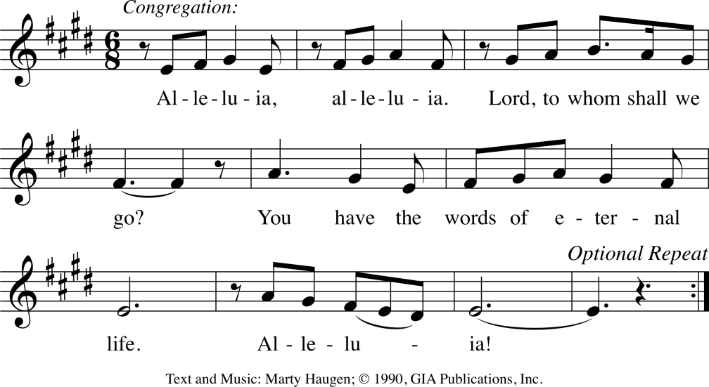

Gospel Reading
After reading –Leader: The Gospel of the Lord.
Congregation: Thanks be to God.

John 16: 12-15
‘I still have many things to say to you, but you cannot bear them now. When the Spirit of truth comes, he will guide you into all the truth; for he will not speak on his own, but will speak whatever he hears, and he will declare to you the things that are to come. He will glorify me, because he will take what is mine and declare it to you. All that the Father has is mine. For this reason I said that he will take what is mine and declare it to you.

Sermon
Sermon Hymn “Holy, Holy, Holy, Lord God Almighty!”

Affirmation of Faith

We believe in God, the Creator, who moved upon the face of the deep at the beginning of creation, who created all that is, all that will be, who spoke through the prophets of old.
We believe in Jesus Christ, into whom God’s Spirit was poured in fullness and power, that the whole creation might be restored, healed and unified; and who promised that the Spirit would come and fill the faithful with power to witness to the mighty love of God.
We believe in the Holy Spirit, who breathes within us the breath of God. We wait on the Spirit today with longing hearts, seeking to be empowered to witness to God’s love in Christ, with fresh and courageous actions of love and hope. Amen.
Prayers of the People

Offering

Offering Response “As the Grains of Wheat”

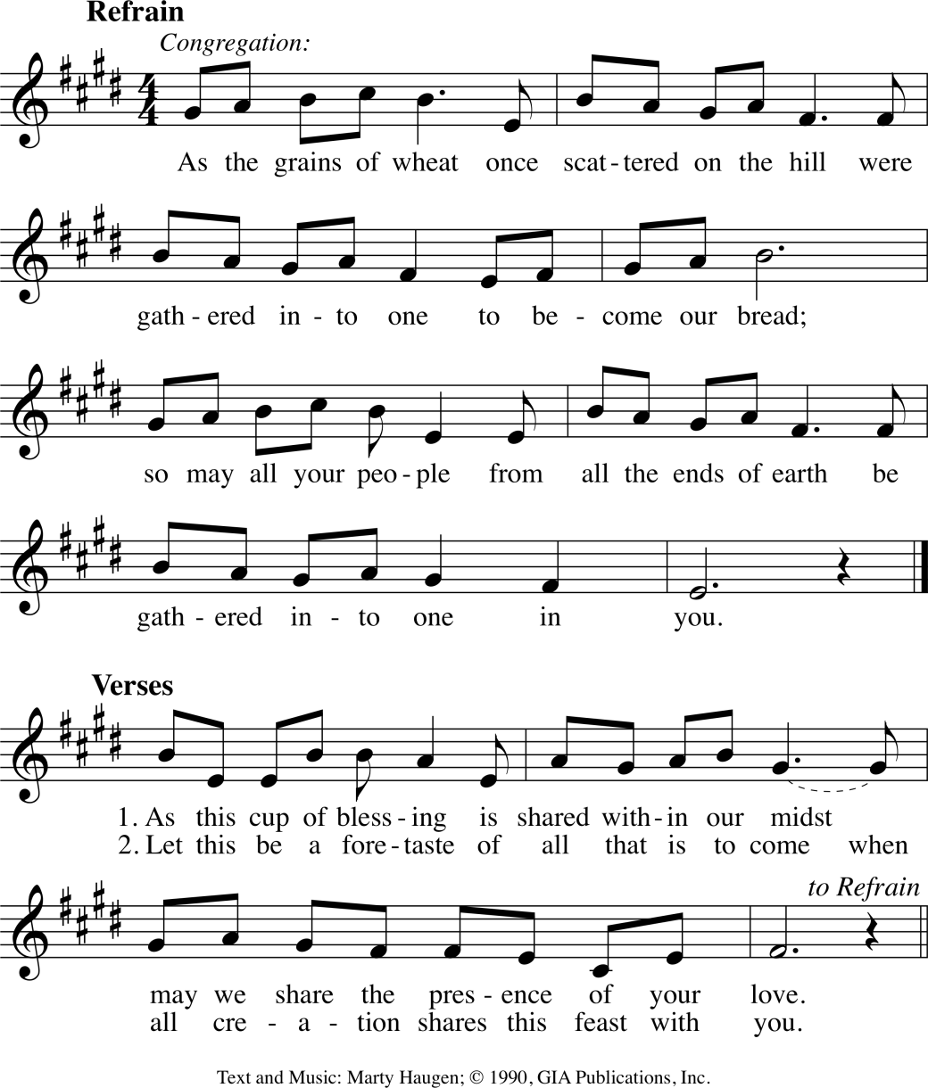

Leader: Let us pray. Merciful God,
ALL: Everything in heaven and earth belongs to you. We joyfully release what you have entrusted to us. May these gifts be signs of our whole lives returned to you, dedicated to the healing and unity of all creation, through Jesus Christ. Amen

The Great Thanksgiving

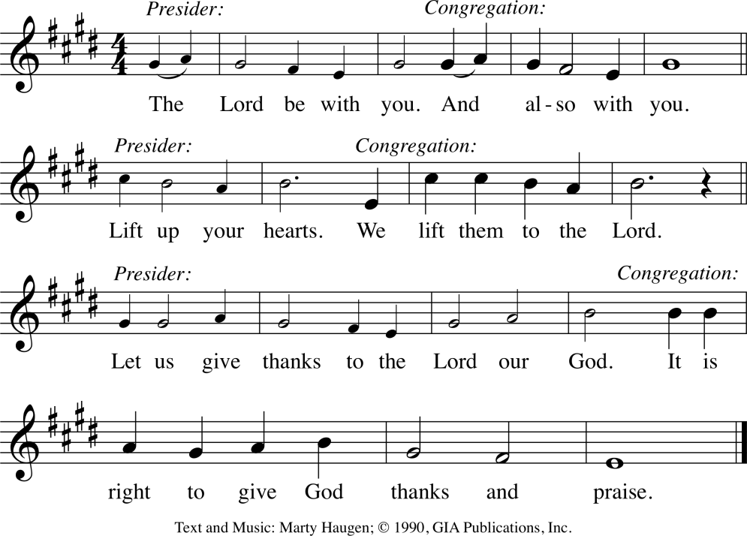
Pastor: It is our duty and delight … we praise your name and join their unending hymn:

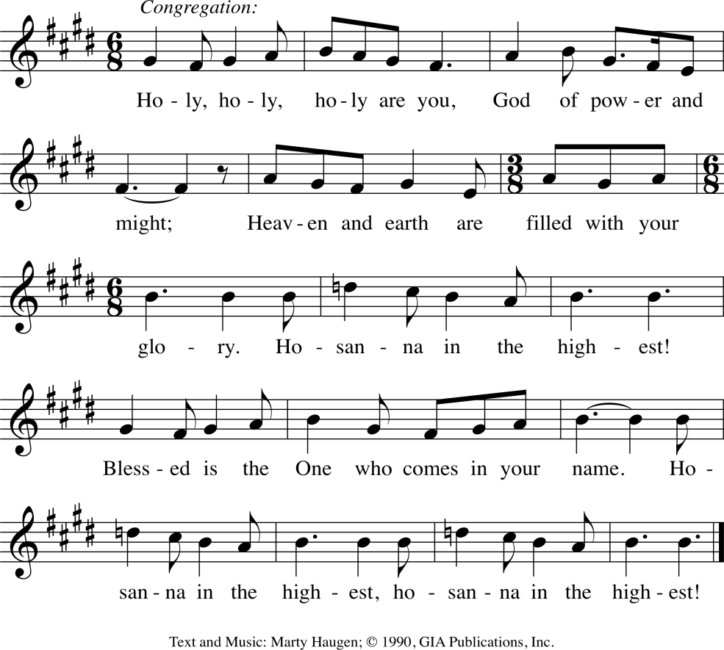

Eucharistic Prayer and Acclamations

Eucharistic Acclamation 2
Pastor: Amen. Come, Lord Jesus. Amen. Come, Lord Jesus.

Eucharistic Acclamation 3
Pastor: Amen. Come, Holy Spirit. Amen. Come, Holy Spirit.

“Through Christ, with Christ, in Christ”

Words of Institution

Leader: Lord, Remember us in your love, and teach us to pray;
ALL: Our Father, who art in heaven, hallowed be thy name, thy kingdom come, thy will be done, on earth as it is in heaven. Give us this day our daily bread; and forgive us our trespasses, as we forgive those who trespass against us; and lead us not into temptation, but deliver us from evil. For thine is the kingdom, and the power, and the glory, forever and ever. Amen.

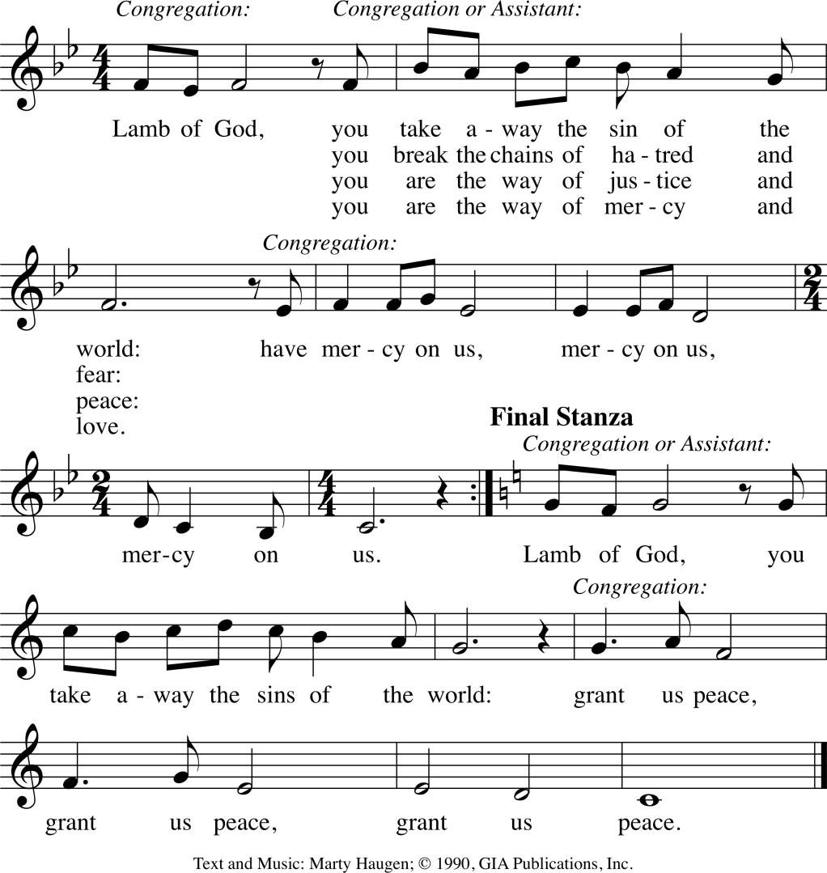
Distribution of Communion

We welcome all people who come in the faith to partake of Holy Communion. Smaller children are invited to come forward for a blessing. Grape juice and gluten free wafers are available, ask server as you approach.

After Communion Blessing and Prayer

Leader: The body and blood of our Lord Jesus Christ strengthen you and give you grace, mercy and peace now and in all your days. ALL: Amen

Leader: Life-giving God, in this meal you have bound us to yourself, from this table we have received the very presence of Jesus Christ. Send us now to be what we have received, that all creation might know your love and sing your praise now and always. ALL: Amen

Sending Song: “Praise to You, O God of Mercy”

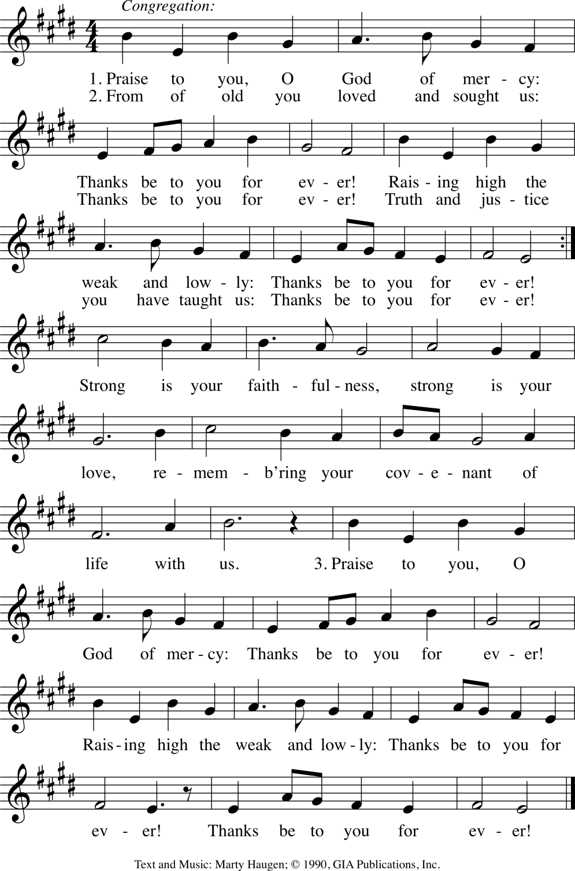
Return to Verse 2

Benediction and Sending

Leader: Go in Peace, Serve the Lord. All: THANKS BE TO GOD!!

Music and lyric reproduce by permission under One License #A-705-815 and CCLI license # 1580664

