Lord of the Valley Lutheran Church
PO Box 843 Granby, CO 80446 (970)887-9252
Ministers: All God’s People Pastor: Brian Bergum
__________________________________________________________________

LOTV Worship with Holy Communion
Sunday, November 28th First Sunday of Advent

Welcome and Announcements

Leader: We worship as we live, in the name of the Father, the Son, and the Holy Spirit.
People: Amen

Leader: The days grow short and the darkness of these days reminds us of the darkness of sin and brokenness. So we put up lights, to remember the Light of Christ that shines in our darkness, in all darkness.
People: We hear the cry of the prophets, the greeting of the angel, and wonder. The Spirit of God is upon us and we proclaim the good news: Nothing is impossible with God! Come Lord Jesus.

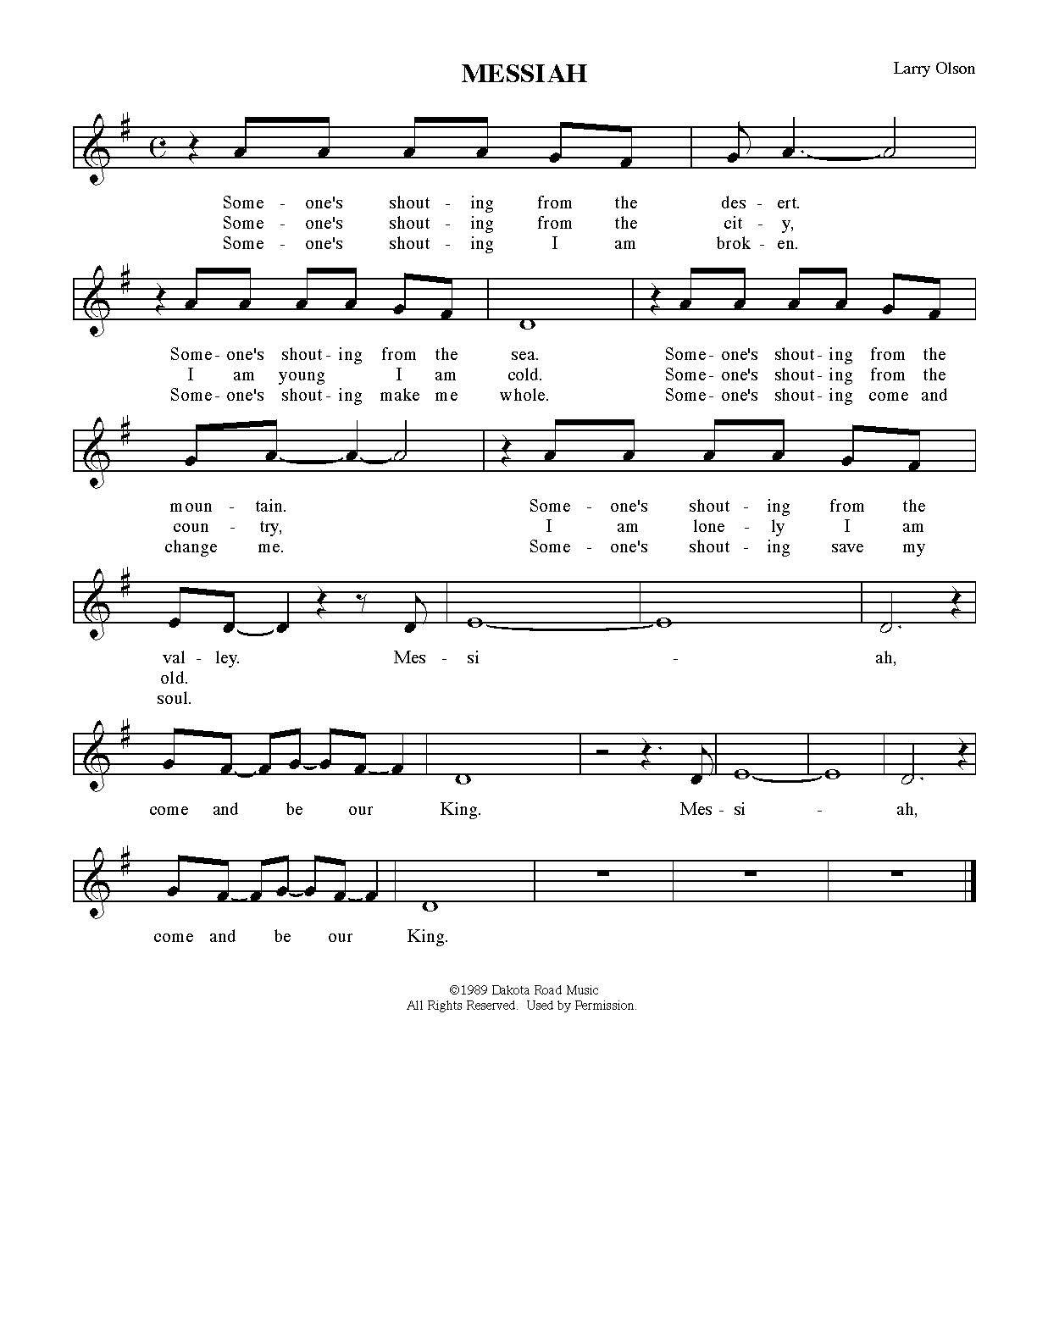

Confession and Forgiveness

Leader: Advent is a season to open our lives to the presence of God. Advent is an awareness that we are made whole through the hope, peace, joy and love that comes only from God.

(A Time of Silence for Personal Reflection and Confession.)

Leader: Most merciful God,
People: We confess that we have sinned against you by our thoughts, by our words, and by our actions. In this season of Advent, we pray that you would enable us to watch for your light, signs of where you are breaking through the tinsel and glitter we use to mask our pain, our guilt, and our fear. Help us hear the words of Your angels, “Do not fear”, and trust that you are with us. Forgive us. Fill us with your love. Amen.

Leader: We are people who walk in darkness, but even in our darkness there is a light that the world can not diminish. The Light of God has come to us in Jesus Christ. It is the light of love, of life, of hope. If you hear nothing else during our worship today, hear this: that God loves you and forgives you and calls you to bear the light of Christ in your lives.
People: Amen. Thanks be to God!!!

Lighting of the Advent Wreath

Leader: The Gospel of John speaks of Christ as the true light coming into the world. In celebration of this, we light candles for the four weeks leading to Christmas and reflect on the coming of Christ. Christ is always coming, always entering an anxious time, a troubled world, a wounded heart. And so today we light one candle, a candle of hope, and dare to express our longing for hope, for healing, and the well-being of creation.
People: Loving God, as we enter this Advent season, we open all the dark places in our lives and memories to the healing light of Christ. Show us the creative power of hope. Prepare our hearts to be transformed by you that we may walk in the light of Christ. Amen.

Scripture Readings

After each reading –
Reader: The Word of God for the People of God.
ALL: Thanks be to God.

Jeremiah 33: 14-16
The days are surely coming, says the Lord, when I will fulfil the promise I made to the house of Israel and the house of Judah. In those days and at that time I will cause a righteous Branch to spring up for David; and he shall execute justice and righteousness in the land. In those days Judah will be saved and Jerusalem will live in safety. And this is the name by which it will be called: ‘The Lord is our righteousness.’

1 Thessalonians 3: 9-13
How can we thank God enough for you in return for all the joy that we feel before our God because of you? Night and day we pray most earnestly that we may see you face to face and restore whatever is lacking in your faith.
Now may our God and Father himself and our Lord Jesus direct our way to you. And may the Lord make you increase and abound in love for one another and for all, just as we abound in love for you. And may he so strengthen your hearts in holiness that you may be blameless before our God and Father at the coming of our Lord Jesus with all his saints.

Gospel Reading

After reading – Pastor: The Gospel of the Lord.
Congregation: Thanks be to God.
Luke 21: 25-36
[Jesus said:] ‘There will be signs in the sun, the moon, and the stars, and on the earth distress among nations confused by the roaring of the sea and the waves. People will faint from fear and foreboding of what is coming upon the world, for the powers of the heavens will be shaken. Then they will see “the Son of Man coming in a cloud” with power and great glory. Now when these things begin to take place, stand up and raise your heads, because your redemption is drawing near.’
Then he told them a parable: ‘Look at the fig tree and all the trees; as soon as they sprout leaves you can see for yourselves and know that summer is already near. So also, when you see these things taking place, you know that the kingdom of God is near. Truly I tell you, this generation will not pass away until all things have taken place. Heaven and earth will pass away, but my words will not pass away.
‘Be on guard so that your hearts are not weighed down with dissipation and drunkenness and the worries of this life, and that day does not catch you unexpectedly, like a trap. For it will come upon all who live on the face of the whole earth. Be alert at all times, praying that you may have the strength to escape all these things that will take place, and to stand before the Son of Man.’

Sermon

Song “Give Thanks”

The Apostles’ Creed

I believe in God, the Father almighty,
creator of heaven and earth.
I believe in Jesus Christ, God’s only Son, our Lord,
who was conceived by the Holy Spirit,
born of the virgin Mary,
suffered under Pontius Pilate,
was crucified, died, and was buried;
he descended to the dead.*
On the third day he rose again;
he ascended into heaven,
he is seated at the right hand of the Father,
and he will come to judge the living and the dead.
I believe in the Holy Spirit,
the holy catholic church,
the communion of saints,
the forgiveness of sins,
the resurrection of the body,
and the life everlasting. Amen.

Prayers of the People

Offering

The Great Thanksgiving

Leader: The Lord be with you.
People: And also with you.

Leader: Lift up your hearts.
People: We lift them up to God.

Leader: Let us give thanks to the Lord our God.
People: It is right to give God thanks and praise.

Leader: All praise to You, Emmanuel, God-promised, and God with us; Your light shines in our lives; your peace embraces our anger, sorrow, and loss; your life opens us to new discovery of ourselves and our neighbors. And so it is with courage and hope that we join in singing the song of Mary, praising you with our joyful hearts.

The Annunciation
Leader: An angel went from God to a town called Nazareth to a woman whose name was Mary. The angel said to her, “Rejoice, O highly favored, for God is with you. You shall bear a child, and his name shall be Jesus, the Chosen One of God Most High.” And Mary said, “I am the servant of my God, I live to do your will.”

The Magnificat

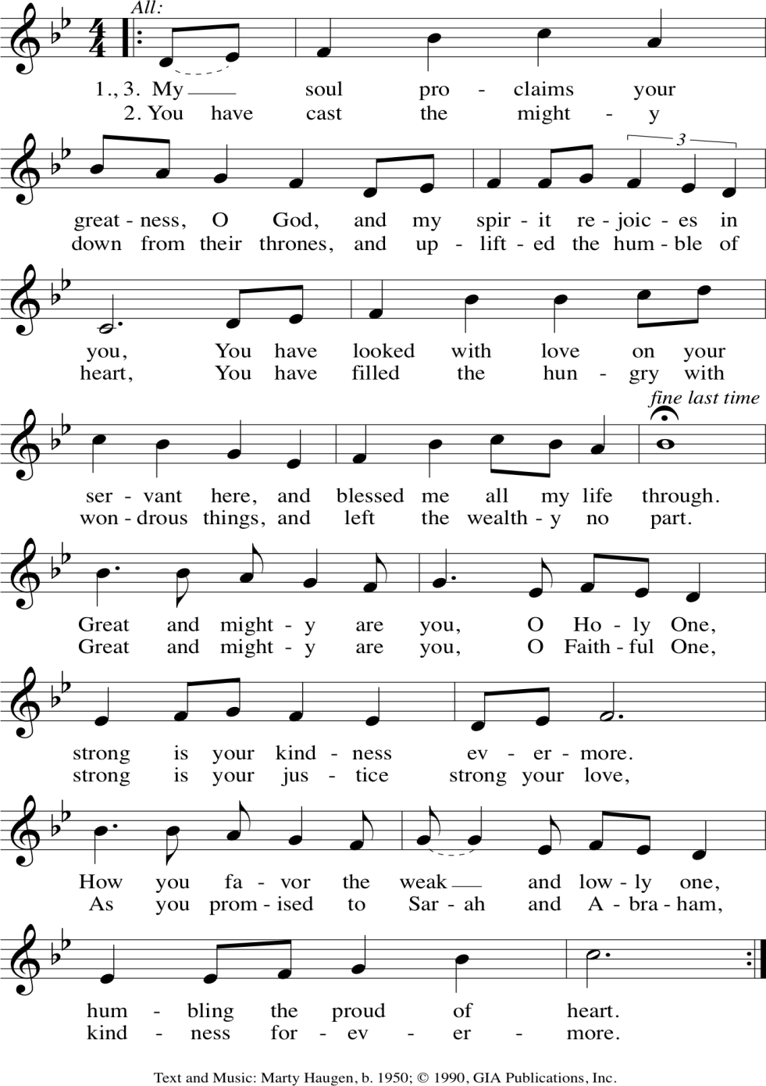

Words of Institution

O Holy One, the beginning and the end, the giver of life: Blessed are you for the birth of creation. Blessed are you in the darkness and in the light. Blessed are you for your promise to your people. Blessed are you in the prophets’ hopes and dreams. Blessed are you for Mary’s openness to your will. Blessed are you for your Son Jesus, the Word made flesh.
In the night in which he was betrayed, our Lord Jesus took bread, and gave thanks; broke it, and gave it to his disciples, saying: Take and eat; this is my body, given for you. Do this for the remembrance of me. Again after supper he took the cup, gave thanks, and gave it for all to drink, saying: This cup is the new covenant in my blood, shed for you and for all people for the forgiveness of sin. Do this for the remembrance of me. With this bread and cup we remember your Word dwelling among us, full of grace and truth. We remember our new birth in his death and resurrection. We look with hope for his coming. Holy God, we long for your Spirit. Come among us. Bless this meal. May your Word take flesh in us. Awaken your people. Fill us with your light. Bring the gift of peace on earth. All praise and glory are yours, Holy One of Israel, Word of God incarnate, Power of the Most High, one God, now and forever.
People: Amen.
Leader: Lord, Remember us in your love, and teach us to pray.
ALL: Our Father, who art in heaven, hallowed be thy name. Thy kingdom come. Thy will be done, on earth as it is in heaven. Give us this day our daily bread; and forgive us our trespasses as we forgive those who trespass against us; and lead us not into temptation, but deliver us from evil. For thine is the kingdom and the power, and the glory, forever and ever. Amen

Distribution of Communion

Leader: Life-giving God, in this meal you have bound us to yourself, at this table we have received the very presence of Jesus Christ. Send us now to be what we have received, that all creation might know your love and sing your praise now and always.
ALL: Amen

Benediction
Leader: The Lord bless you and keep you, the Lord’s face shine on you and be gracious to you, the Lord look upon you with favor, and give you peace. In the name of the Father and of the Son, and of the Holy Spirit. Amen.

Sending

Leader: Go in hope to love and serve the Lord!
ALL: Thanks be to God.

Music and lyric reproduce by permission under One License #A-705-815 and CCLI license # 1580664

