Lord of the Valley Lutheran Church
PO Box 843 Granby, CO 80446 (970)887-9252
Ministers: All God’s People Pastor: Brian Bergum
__________________________________________________________________

LOTV Worship Sunday, August 15th, 2021 / 12th Sunday after Pentecost

Welcome and Announcements / Worship and Fellowship Notes
As we continue to move through this time of transition, we are mindful that people will have different comfort levels regarding some of our worship and fellowship practices. We encourage everyone to receive Holy Communion, but recognize that not all will be comfortable coming forward to receive the communion elements from our communion assistants. Therefore, we will continue to make the pre-packaged elements available in our chairs as an alternative means of receiving this taste of grace.
Likewise, there may be different preferences regarding our fellowship time following worship. We invite all to participate as each is comfortable. Some may prefer to enjoy conversation outside or in the sanctuary. Others may wish to go to the kitchen and get a cup of coffee and/or a simple snack and bring it to the sanctuary or step outside; while others may be comfortable sitting down in the fellowship room for conversation. Please avoid gathering in the kitchen so people can move freely around the island. Please enjoy this Fellowship opportunity in a way that best matches your comfort level.
As for our worship assistants, we do ask that our Communion Assistants be fully vaccinated due to the closeness required in distributing the elements to those coming forward. This is a precaution we’ll practice for the time going forward, being mindful that risks do remain during this pandemic.
Thank you for your care and support of one another as we gather in worship and fellowship.

Tree of Life

Call to Worship – Order of Confession and Forgiveness

Leader: We worship as we live, in the Grace of God, the Compassion of Jesus Christ, and the Healing Hope of the Holy Spirit.
ALL: Amen

Leader: We have come to praise God, who has done wonderful things among us.
Leader: You are indeed Holy, Gracious and Merciful God … This we pray through Jesus Christ our Savior and our Friend.

Leader: Lord remember us in your kingdom and teach us to pray:
All: Our Father, who art in heaven, hallowed be thy name. Thy Kingdom come, thy will be done, on earth as it is in heaven. Give us this day our daily bread; and forgive us our trespasses as we forgive those who trespass against us. And lead us not into temptation but deliver us from evil; for thine is the kingdom, and the power and the glory, forever and ever. Amen

Communion is Shared

Post Communion Blessing

Leader: The body and blood of our Lord Jesus Christ, give you grace, mercy and peace now and in all your days!
All: Amen

Leader: Life-giving God, in this meal you have bound us to yourself, at this table we have received the very presence of Jesus Christ. Send us now to be what we have received, that all creation might know your love and sing your praise now and always.
All: Amen

Blessing and Sending

Leader: Go in Peace, Serve the Lord
ALL: THANKS BE TO GOD!!

Music and lyric reproduce by permission under One License #A-705-815 and CCLI license # 1580664

Affirmation of Faith “Apostles Creed”

I believe in God, the Father almighty,
creator of heaven and earth.
I believe in Jesus Christ, God’s only Son, our Lord,
who was conceived by the Holy Spirit,
born of the virgin Mary,
suffered under Pontius Pilate,
was crucified, died, and was buried;
he descended to the dead.
On the third day he rose again;
he ascended into heaven,
he is seated at the right hand of the Father,
and he will come to judge the living and the dead.
I believe in the Holy Spirit,
the holy catholic church,
the communion of saints,
the forgiveness of sins,
the resurrection of the body,
and the life everlasting. Amen.

Prayers of the People

The Great Thanksgiving

Leader: The Lord be with you
All: And also with you.

Leader: Lift up your hearts.
All: We lift them to God.

Leader: Let us give thanks to God Most High.
All: It is right to give God our thanks and praise.
ALL: In Jesus Christ, God has shown us love, giving light for our darkness, and strength for all our days.

Leader: We come remembering Christ’s life and ministry, and the life we are called to live.
ALL: We come as people yearning, searching for ways to live out our faith. We come, seeking direction and strength to carry on our journey.

Leader: Come, you are welcome here. Christ is with us, calling us now to life and love.
ALL: Let us celebrate life. Let us worship God.

Leader: In Jesus Christ, the Light of God is made known to the world. As we gather we confess to God and to each other the ways in which we deny and refuse to live by the Light of Christ in our lives.

(A Time of Silence for Personal Reflection and Confess)

ALL: We confess to you the truth of our broken lives. We have not trusted your promises or walked in your ways. We have hoarded and squandered the gifts of creation. We have failed to welcome the stranger and the outcast, and make room for those in need. We have neither worked to release the oppressed nor admitted our own captivities. We have failed to let your light shine through us in the world in which we live. Forgive our sin, heal our lives, and set us free, that we might live with your whole creation in joy and hope. Amen

Leader: The people who walked in darkness have seen a great light. Upon them, upon us, the light of Christ shines. Fear not! For behold I bring you good news of great joy: God loves you, and in and through this love God forgives you of all your sins. Embrace this day, for God has come to you, to abide in you. Arise! Your Light has come.
ALL: Amen. Thanks be to God!!!

Leader: The grace of our Lord Jesus Christ, the love of God, and the communion of the Holy Spirit be with you all.
All: And also with you.
Gathering Song “Come and Gather Beneath the Tree of Life”

Song “We Eat the Bread of Teaching”

Song of Praise “Within the Reign of God”
(The congregation sings the verse response and the refrain)

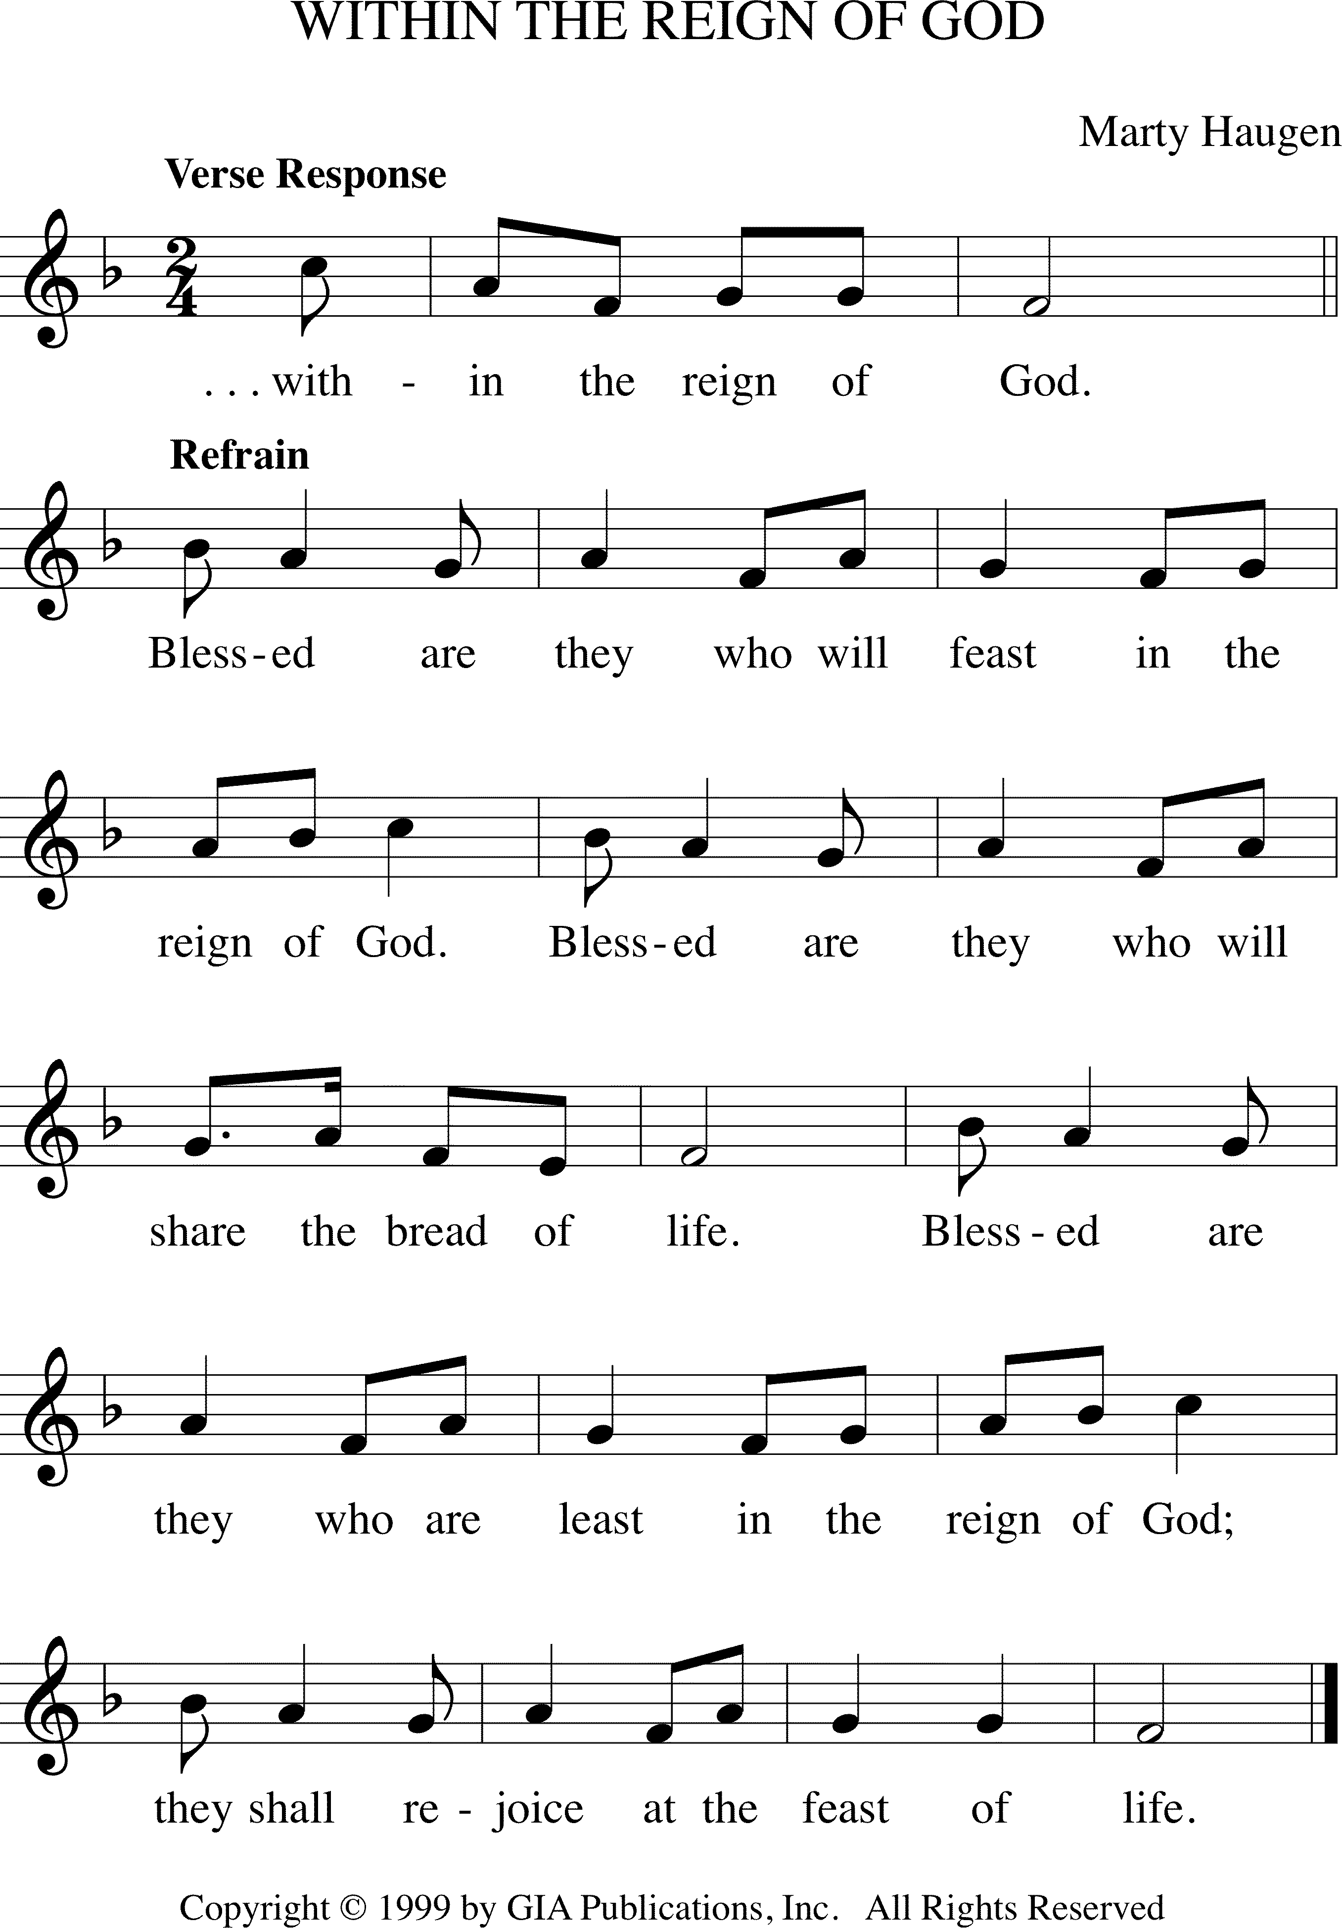

Verse: Come now, the feast is spread; in Jesus’ name we break the bread,
Here shall we all be fed, WITHIN THE REIGN OF GOD
All you who seek God’s face are welcome in this holy place;
Join in the feast of grace, WITHIN THE REIGN OF GOD (Refrain)

Verse: Welcome the weak and poor, the sinner finds an open door,
None judged, and none ignored WITHIN THE REIGN OF GOD
Here shall the weary rest, the stranger be a welcome guest.
So shall we all be blest, WITHIN THE REIGN OF GOD (Refrain)

Verse: One earth, one holy band, one family as our God has planned,
All share the promised land, WITHIN THE REIGN OF GOD
Come now, the feast is spread, in Jesus’ name we break the bread;
Here shall we all be fed, WITHIN THE REIGN OF GOD (Refrain)
Song of Praise “Within the Reign of God”
(The congregation sings the verse response and the refrain)

Verse: Come now, the feast is spread; in Jesus’ name we break the bread,
Here shall we all be fed, WITHIN THE REIGN OF GOD
All you who seek God’s face are welcome in this holy place;
Join in the feast of grace, WITHIN THE REIGN OF GOD (Refrain)

Verse: Welcome the weak and poor, the sinner finds an open door,
None judged, and none ignored WITHIN THE REIGN OF GOD
Here shall the weary rest, the stranger be a welcome guest.
So shall we all be blest, WITHIN THE REIGN OF GOD (Refrain)

Verse: One earth, one holy band, one family as our God has planned,
All share the promised land, WITHIN THE REIGN OF GOD
Come now, the feast is spread, in Jesus’ name we break the bread;
Here shall we all be fed, WITHIN THE REIGN OF GOD (Refrain)
Prayer of the Day

Leader: The Lord is with you.
All: And also with you.

Leader: Ever-loving God,
All: your Son gives himself as living bread for the life of the world. Fill us with such a knowledge of his presence that we may be strengthened and sustained by his risen life to serve you continually, through Jesus Christ, our Savior and Lord. Amen.

Scripture Readings

After each reading –
Reader: The Word of God for the People of God.
ALL: Thanks be to God.

Gospel Reading

After reading – Pastor: The Gospel of the Lord.
Congregation: Thanks be to God.

Sermon
Prayer of the Day

Leader: The Lord is with you.
All: And also with you.

Leader: Ever-loving God,
All: your Son gives himself as living bread for the life of the world. Fill us with such a knowledge of his presence that we may be strengthened and sustained by his risen life to serve you continually, through Jesus Christ, our Savior and Lord. Amen.

Scripture Readings

After each reading –
Reader: The Word of God for the People of God.
ALL: Thanks be to God.

Gospel Reading

After reading – Pastor: The Gospel of the Lord.
Congregation: Thanks be to God.

Sermon

