Lord of the Valley Lutheran Church
PO Box 843 Granby, CO 80446 (970)887-9252
Ministers: All God’s People Pastor: Joel Pancoast
__________________________________________________________________

LOTV Worship with Holy Communion
Sunday, July 19, 2026 8th Sunday after Pentecost

GATHERING

Welcome & Announcements

Welcoming One Another with Christ’s Peace
P: The peace of Christ be with you always.
C: And also with you.
Because Lord of the Valley is a welcoming church, we take a moment to share Christ’s peace and greet one another, especially if there is someone you haven’t met or seen in a while, so that we can worship together in peace and unity.

Opening Litany

Leader: On the road to Emmaus, the risen Christ came alongside his disciples.
People: Christ comes alongside us still.

Leader: He invited them to tell their story.
People: We bring before God the story of this congregation—our joys, our challenges, our hopes, and our prayers.

Leader: He opened the Scriptures and revealed God's faithfulness.
People: We gather to hear God's story and to be shaped by God's Word.

Leader: He was made known to them in the breaking of the bread.
People: We gather around Christ's table, where we are nourished by grace.

Leader: Their hearts were set ablaze, and they returned with joy to the community of believers.
People: We are part of Christ's Church—joined with congregations throughout the Rocky Mountain Synod and around the world.

Leader: Together we worship.
People: Together we listen.

Leader: Together we serve.
People: Together we follow Christ into the world.

Leader: Come, let us walk with the risen Christ.
People: Come, let us worship God!

Gathering Song “Gather Us In” ELW 532

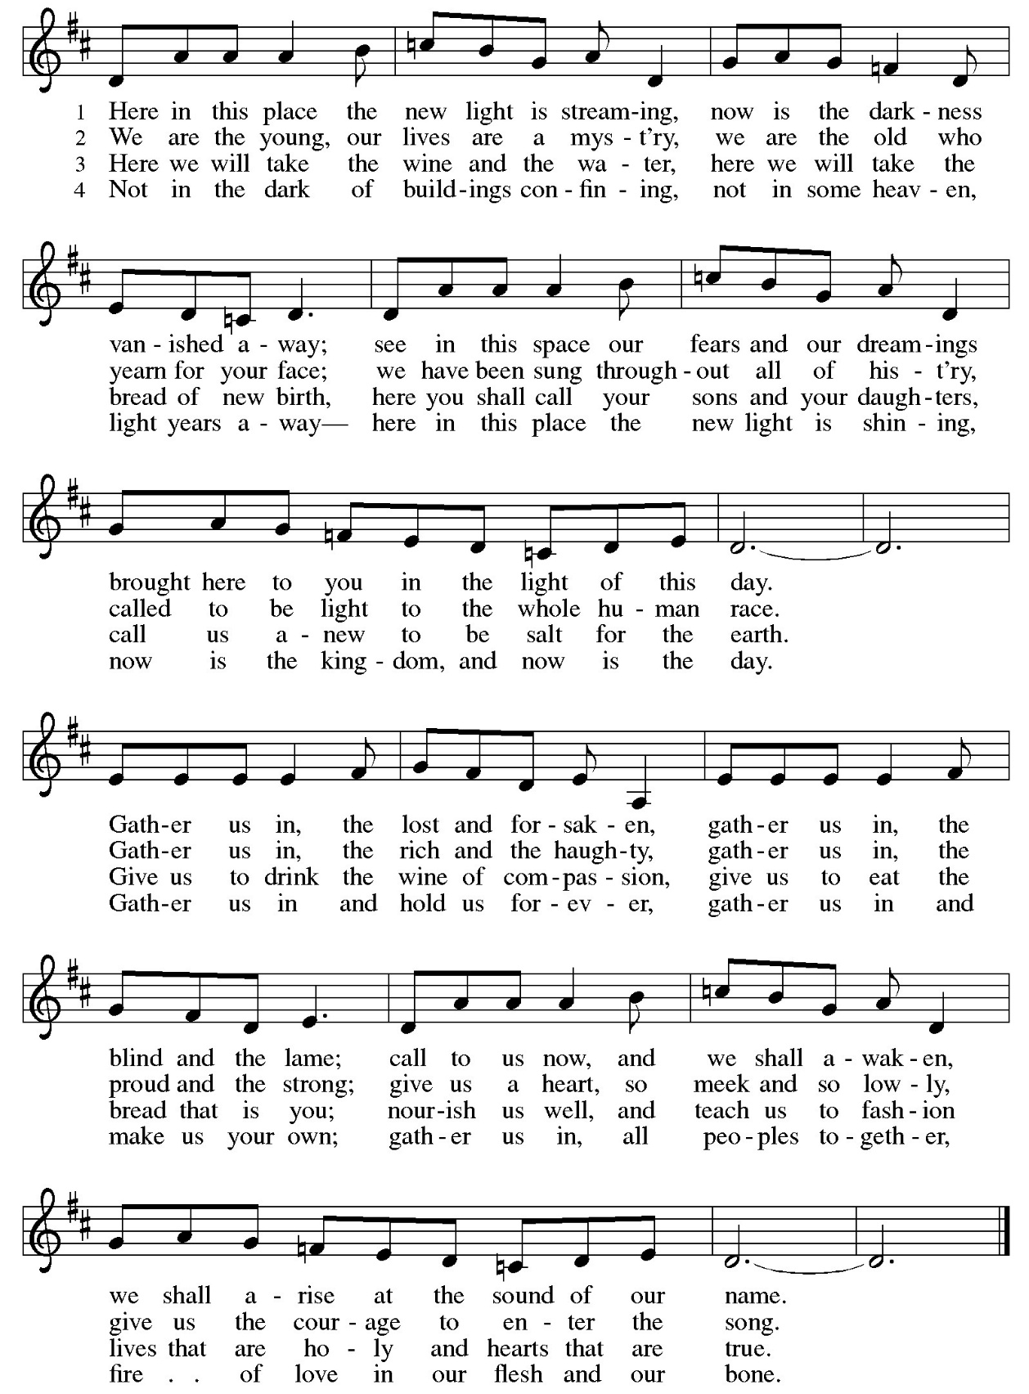
Thanksgiving for Baptism

Joined to Christ in the waters of baptism, we are united with Christians in every time and place, clothed with God's mercy and forgiveness. Let us give thanks for the gift of baptism.

Holy God, holy and merciful, holy and mighty, you are the river of life,
you are the everlasting wellspring, you are the fire of rebirth.
Glory to you for oceans and lakes, for rivers and streams.

Honor to you for cloud and rain, for dew and snow.
Your waters are below us, around us, above us: our life is born in you.
You are the fountain of resurrection.

Praise to you for your saving waters:
Noah and the animals survive the flood, Hagar discovers your well.
The Israelites escape through the sea, and they drink from your gushing rock.
Naaman washes his leprosy away,
and the Samaritan woman will never be thirsty again.

Praise to you for the water of baptism and for your Word
that saves us in this sacrament.
Breathe your Spirit into all who are gathered here and into all creation.
Illumine our days. Enliven our bones. Dry our tears.
Wash away the sin within us and drown the evil around us.

Satisfy all our thirst with your living water, Jesus Christ, our Savior,
who lives and reigns with you and the Holy Spirit, one God, now and forever.
Amen.

A: Trusting in God’s promise that all of our sins are washed away in the waters of baptism, let us sing our praise and thanks to God! The pastor will sing each line, and you are invited to repeat with me.

Glory to God

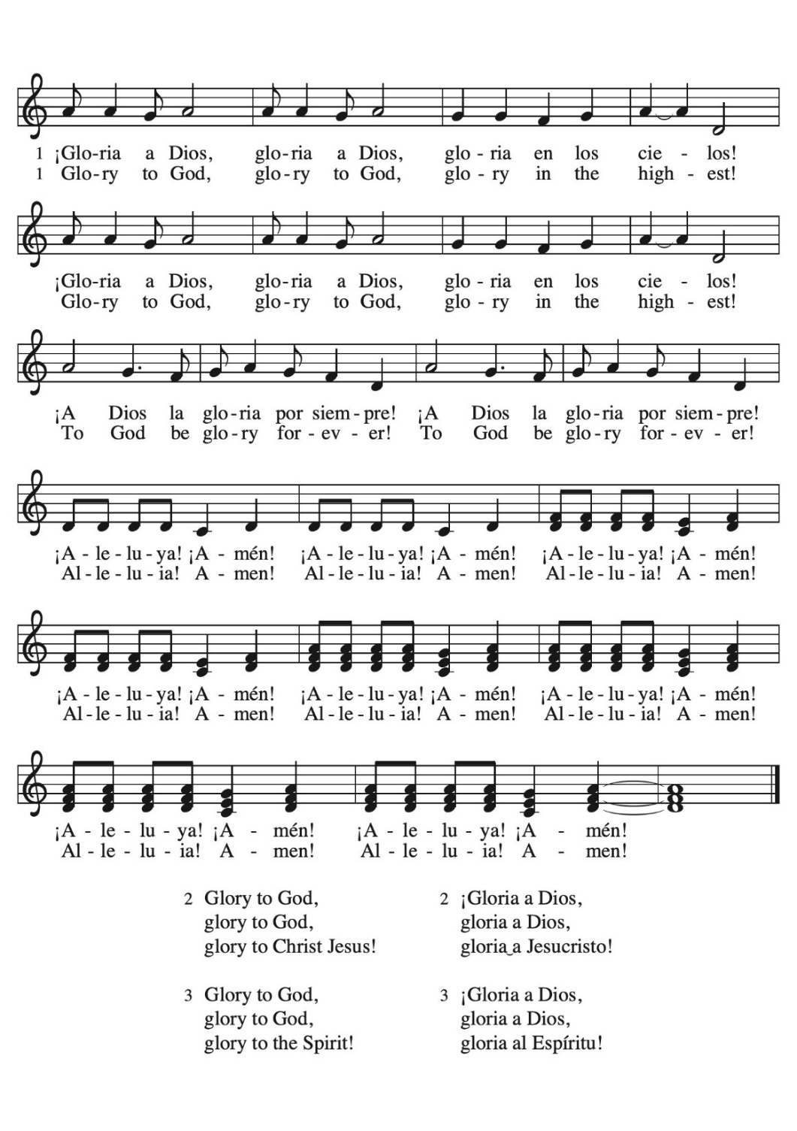

Song Continues on Next Page…

Greeting

P: The grace of our Lord Jesus Christ,
the love of God, and
the communion of the Holy Spirit be with you all.
C: And also with you.

Prayer of the Day
A: Let us pray…God our Creator, your Son Jesus prayed that his followers might be one. Unite your Church so that, strengthened by your Word, nourished at your table, and sent together in your mission, we may carry to the world the message of your love; through Jesus Christ, our Savior and Lord. Amen.
WORD

Scriptures

Psalm 46
¹God is our refuge and strength,
a very present help in trouble.
²Therefore we will not fear, though the earth be moved,
and though the mountains shake in the depths of the sea;
³though its waters rage and foam,
and though the mountains tremble with its tumult.
⁴There is a river whose streams make glad the city of God,
the holy habitation of the Most High.
⁵God is in the midst of the city; it shall not be shaken;
God shall help it at the break of day.
⁶The nations rage, and the kingdoms shake;
God speaks, and the earth melts away.
⁷The Lord of hosts is with us;
the God of Jacob is our stronghold.
⁸Come now, regard the works of the Lord,
what desolations God has brought upon the earth;
⁹behold the one who makes war to cease in all the world;
who breaks the bow, and shatters the spear, and burns the shields with fire.
¹⁰“Be still, then, and know that I am God;
I will be exalted among the nations; I will be exalted in the earth.”
¹¹The Lord of hosts is with us;
the God of Jacob is our stronghold.

R: The word of God for the people of God.
C: Thanks be to God.

Romans 12:1-8
¹ I appeal to you therefore, brothers and sisters, on the basis of God’s mercy, to present your bodies as a living sacrifice, holy and acceptable to God, which is your reasonable act of worship. ² Do not be conformed to this age, but be transformed by the renewing of the mind, so that you may discern what is the will of God—what is good and acceptable and perfect.
³ For by the grace given to me I say to everyone among you not to think of yourself more highly than you ought to think but to think with sober judgment, each according to the measure of faith that God has assigned. ⁴ For as in one body we have many members and not all the members have the same function, ⁵ so we, who are many, are one body in Christ, and individually we are members one of another. ⁶ We have gifts that differ according to the grace given to us: prophecy, in proportion to faith; ⁷ ministry, in ministering; the teacher, in teaching; ⁸ the encourager, in encouragement; the giver, in sincerity; the leader, in diligence; the compassionate, in cheerfulness.

R: The word of God for the people of God.
C: Thanks be to God.

Gospel Acclamation

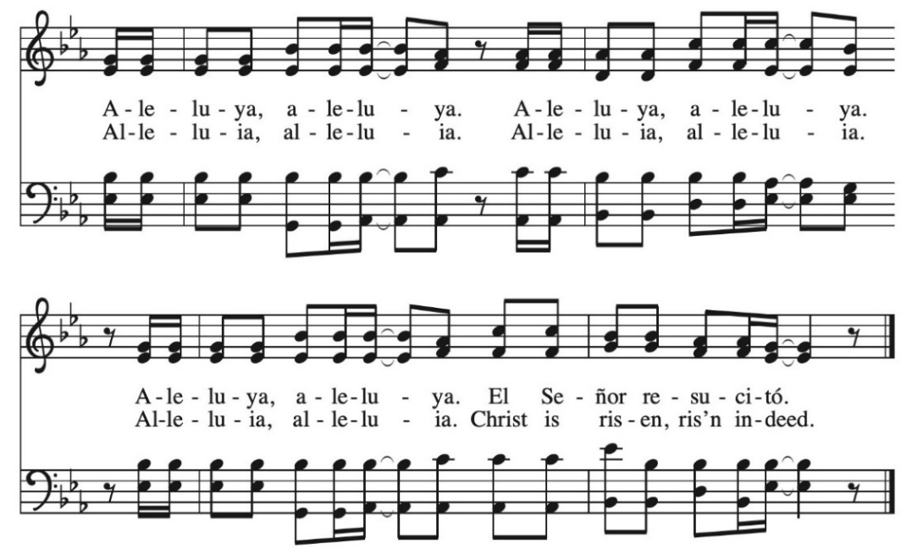

Gospel

Luke 24:13-35

¹³ Now on that same day two of them were going to a village called Emmaus, about seven miles^{[a]} from Jerusalem, ¹⁴ and talking with each other about all these things that had happened. ¹⁵ While they were talking and discussing, Jesus himself came near and went with them, ¹⁶ but their eyes were kept from recognizing him. ¹⁷ And he said to them, “What are you discussing with each other while you walk along?” They stood still, looking sad.^{[b]} ¹⁸ Then one of them, whose name was Cleopas, answered him, “Are you the only stranger in Jerusalem who does not know the things that have taken place there in these days?” ¹⁹ He asked them, “What things?” They replied, “The things about Jesus of Nazareth,^{[c]} who was a prophet mighty in deed and word before God and all the people, ²⁰ and how our chief priests and leaders handed him over to be condemned to death and crucified him. ²¹ But we had hoped that he was the one to redeem Israel.^{[d]} Yes, and besides all this, it is now the third day since these things took place. ²² Moreover, some women of our group astounded us. They were at the tomb early this morning, ²³ and when they did not find his body there they came back and told us that they had indeed seen a vision of angels who said that he was alive. ²⁴ Some of those who were with us went to the tomb and found it just as the women had said, but they did not see him.” ²⁵ Then he said to them, “Oh, how foolish you are and how slow of heart to believe all that the prophets have declared! ²⁶ Was it not necessary that the Messiah^{[e]} should suffer these things and then enter into his glory?” ²⁷ Then beginning with Moses and all the prophets, he interpreted to them the things about himself in all the scriptures.
²⁸ As they came near the village to which they were going, he walked ahead as if he were going on. ²⁹ But they urged him strongly, saying, “Stay with us, because it is almost evening and the day is now nearly over.” So he went in to stay with them. ³⁰ When he was at the table with them, he took bread, blessed and broke it, and gave it to them. ³¹ Then their eyes were opened, and they recognized him, and he vanished from their sight. ³² They said to each other, “Were not our hearts burning within us^{[f]} while he was talking to us on the road, while he was opening the scriptures to us?” ³³ That same hour they got up and returned to Jerusalem, and they found the eleven and their companions gathered together. ³⁴ They were saying, “The Lord has risen indeed, and he has appeared to Simon!” ³⁵ Then they told what had happened on the road and how he had been made known to them in the breaking of the bread.

P: The word of God for the people of God.
C: Thanks be to God.

Children’s Message

Sermon (Pastor Sara Wirth, Rocky Mountain Synod Minister for Transitions and Healthy Ministries)
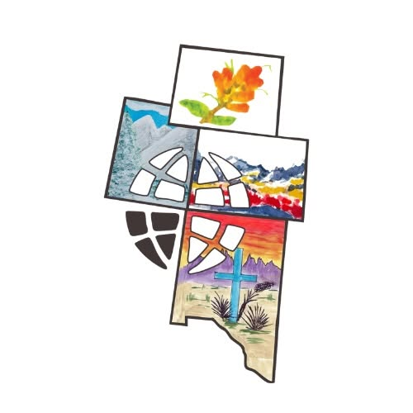
Song of the Day “Day of Arising” ELW 374

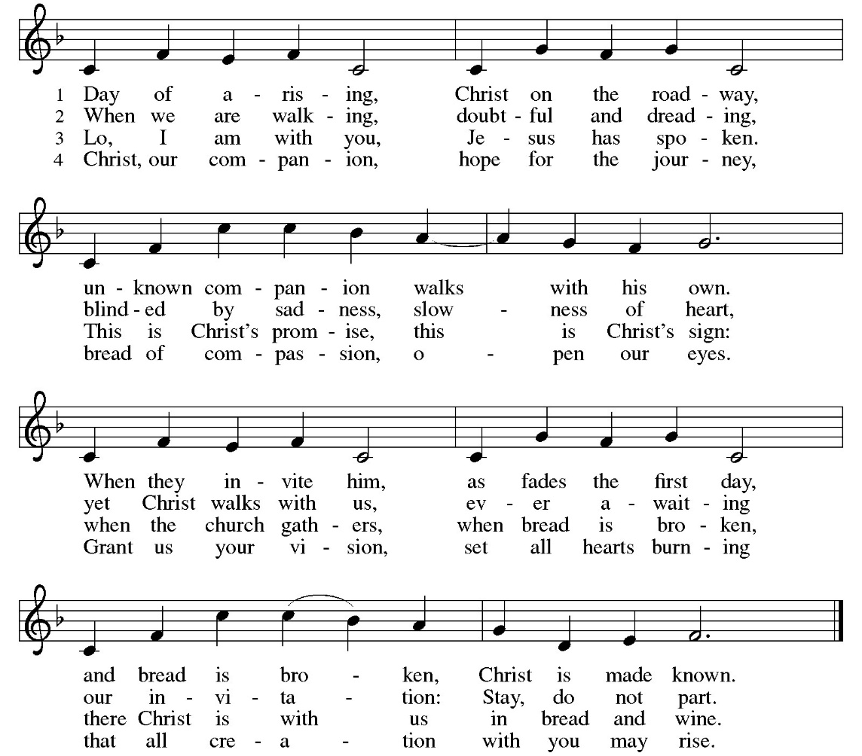

Prayers of the People / Intercessory Prayers

A: …, we pray,
C: hear us when we call.

MEAL

Offering

Offering Prayer
A: Let us pray…With these gifts, gracious God, may your abundance cascade like a waterfall, quenching the thirst of bodies, hearts, and minds in need of replenishing. Thank you for satiating us with your ever-flowing goodness and mercy. Amen.
Words of Institution
“Remember Me” by Gerrit Gustafson, Martin Nystrom
Verse 3
C: So we thank You for the wine
And for the bread
For we see the life You gave
And the blood You shed
And we remember Your wondrous love
You gave Your body You shed Your blood
And we remember Your wondrous love
You gave Your body You shed Your blood

The Lord’s Prayer

P: Lord, remember us in your love and teach us to pray.
C: Our Father, who art in heaven, hallowed be thy name. Thy kingdom come. Thy will be done; on earth as it is in heaven. Give us this day our daily bread; and forgive us our trespasses as we forgive those who trespass against us; and lead us not into temptation, but deliver us from evil; For thine is the kingdom, and the power and the glory forever and ever. Amen.

Distribution of Communion
We invite all who come in faith to the Lord’s Table as we celebrate Holy Communion in our worship today. For those who prefer, grape juice and gluten free wafers are available, let the server know as you approach. Those not communing are welcome to come forward for a blessing.

Holy, Holy, Holy
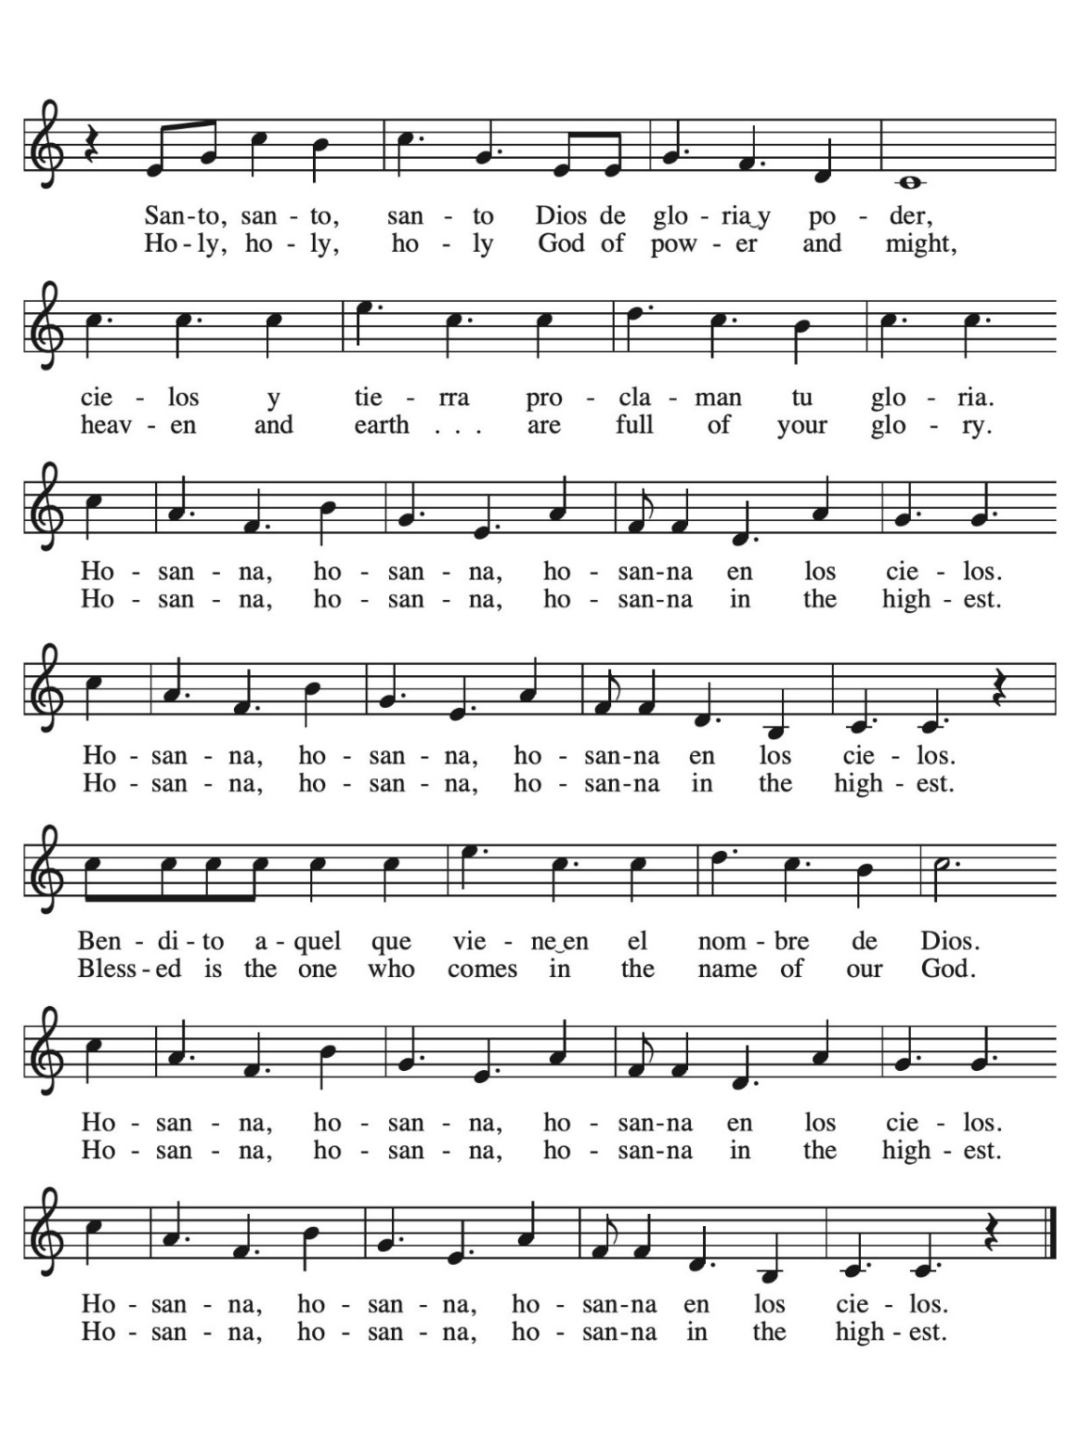

Song Continues on Next Page…

Lamb of God

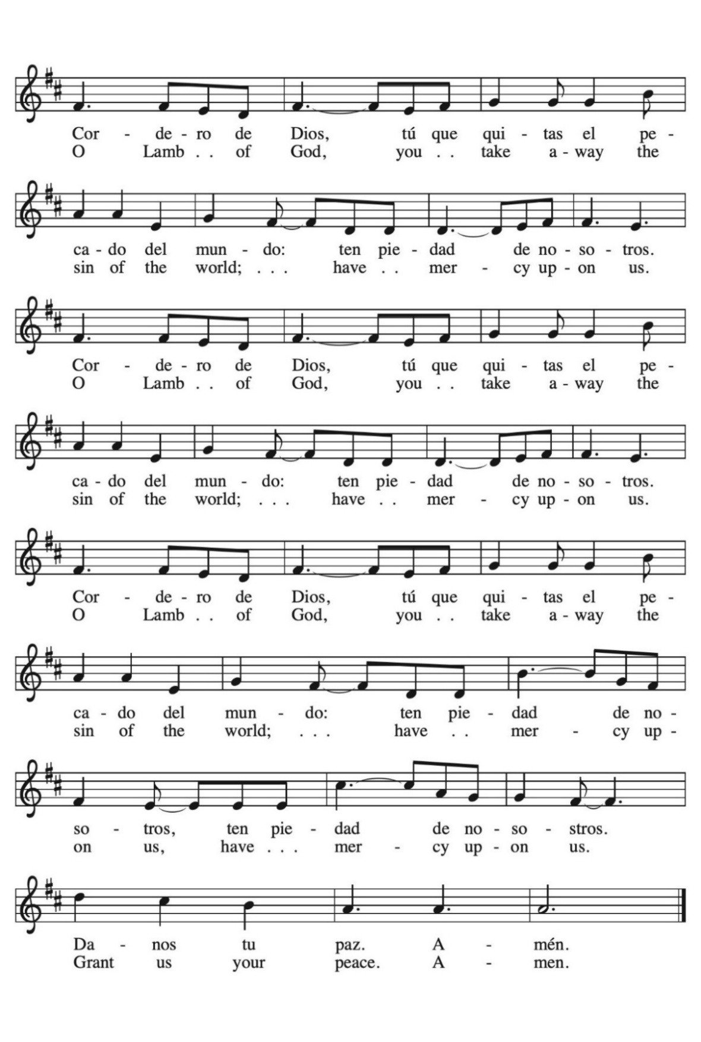

Song Continues on Next Page…

Post-Communion Blessing

Post-Communion Prayer

A: Compassionate God,
C: through the gifts of bread and cup
our hearts are filled with the abundance of your love.
Strengthen us, that we may share your love freely,
as you have shared with us.
We ask this in the name of Jesus,
through the Spirit nourishing us now and forever.
Amen.

SENDING

Benediction

The peace of God, which surpasses all understanding, keep your hearts and minds in the knowledge and love of God, and of his Son Jesus Christ our Lord; and the blessing of God Almighty, the Creator, the Son, and the Holy Spirit, be amongst you, and remain with you always. Amen.
Sending Song “We All Are One in Mission” ELW 576

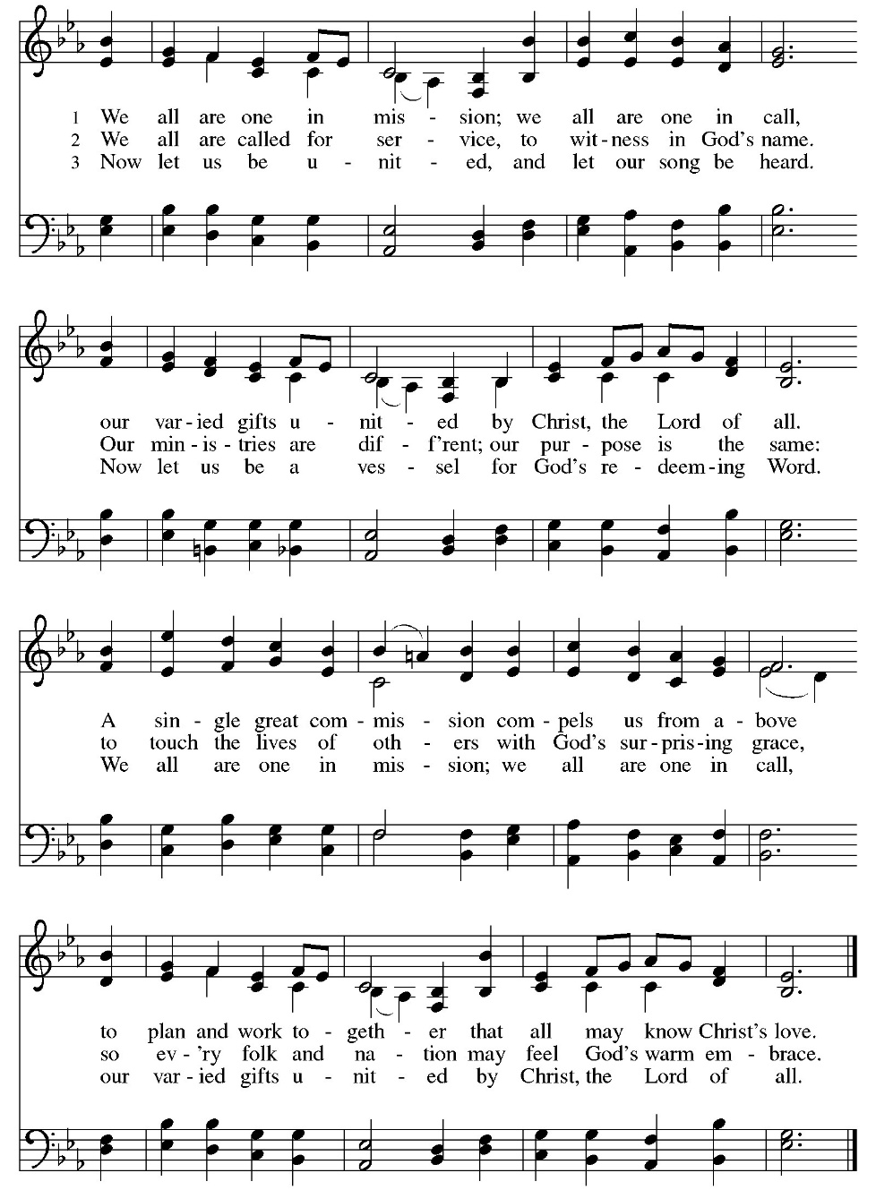

Sending Blessing

A: Go in peace. Christ walks with you.
People: Thanks be to God. And we will.

Liturgies and Music copied with permission under licenses Augsburg Fortress #SB145440, CCLI #1580664, One License A-705-815.

